EXPERIMENT 12
Implementation and Performance Analysis of Decimation and Interpolation in Multirate Signal Processing Using MATLAB
Lokesh A (192512293)
B.E. Electronics and Communication Engineering (ECE)
Experiment Date: 12 October 2026
1. Aim
To implement decimation and interpolation of a discrete-time signal in MATLAB, apply anti-aliasing and anti-imaging FIR filters, and compare the time-domain waveforms and frequency spectra.
2. Objectives
- Generate a composite input signal containing 500 Hz and 1500 Hz components.
- Perform decimation by a factor of M = 2 and observe the change in sampling frequency.
- Apply an anti-aliasing FIR filter before downsampling.
- Perform interpolation by a factor of L = 2 using zero insertion and an anti-imaging FIR filter.
- Plot and compare the original, decimated, upsampled, and interpolated signal spectra.
3. Software Required
MATLAB with Signal Processing Toolbox (for the fir1 function).
4. MATLAB Program
clc; clear; close all;
%% EXPERIMENT 12: MULTIRATE SIGNAL PROCESSING
%% 1. SIGNAL GENERATION
Fs = 8000; % Original sampling frequency
f1 = 500;
f2 = 1500; % Signal frequencies
M = 2; % Decimation factor
L = 2; % Interpolation factor
N = 1000; % Number of samples
fc_dec = 1800; % Anti-aliasing cutoff frequency
fc_interp = 3600; % Anti-imaging cutoff frequency
n = 0:N-1;
t = n/Fs;
x = sin(2*pi*f1*t) + 0.8*sin(2*pi*f2*t);
%% 2. DECIMATION
% Direct downsampling without filtering
x_down_direct = x(1:M:end);
Fs_dec = Fs/M;
% Anti-aliasing FIR filter
b_dec = fir1(60, fc_dec/(Fs/2));
x_dec_filtered = filter(b_dec, 1, x);
% Downsample after filtering
x_dec = x_dec_filtered(1:M:end);
%% 3. INTERPOLATION
% Insert L-1 zeros between input samples
x_up = zeros(1, N*L);
x_up(1:L:end) = x;
Fs_interp = Fs*L;
% Anti-imaging FIR filter designed at interpolated rate
b_interp = L*fir1(60, fc_interp/(Fs_interp/2));
% Filter the upsampled signal
x_interp_filtered = filter(b_interp, 1, x_up);
%% 4. COMMAND WINDOW OUTPUT
fprintf('\\n============================================\\n');
fprintf(' EXPERIMENT 12: MULTIRATE SIGNAL PROCESSING\\n');
fprintf('============================================\\n');
fprintf('Original Sampling Frequency (Fs): %d Hz\\n', Fs);
fprintf('Decimation Factor (M): %d\\n', M);
fprintf('New Sampling Frequency after Decimation: %d Hz\\n\\n', Fs_dec);
fprintf('Interpolation Factor (L): %d\\n', L);
fprintf('New Sampling Frequency after Interpolation: %d Hz\\n\\n', Fs_interp);
fprintf('Signal Lengths:\\n');
fprintf('Original Signal (x): %d samples\\n', length(x));
fprintf('Direct Downsampled Signal: %d samples\\n', length(x_down_direct));
fprintf('Filtered Decimated Signal: %d samples\\n', length(x_dec));
fprintf('Upsampled Signal: %d samples\\n', length(x_up));
fprintf('Interpolated Signal: %d samples\\n\\n', length(x_interp_filtered));
fprintf('Decimation Filter Cutoff: %d Hz\\n', fc_dec);
fprintf('Interpolation Filter Cutoff: %d Hz\\n\\n', fc_interp);
fprintf('Status: Decimation and Interpolation executed successfully.\\n');
fprintf('============================================\\n');
%% 5. SPECTRUM COMPUTATION
Nfft = 2048;
[X_mag, f_x] = compute_spectrum(x, Fs, Nfft);
[X_down_mag, f_down] = compute_spectrum(x_down_direct, Fs_dec, Nfft);
[X_dec_mag, f_dec] = compute_spectrum(x_dec, Fs_dec, Nfft);
[X_up_mag, f_up] = compute_spectrum(x_up, Fs_interp, Nfft);
[X_interp_mag, f_interp] = compute_spectrum(x_interp_filtered, Fs_interp, Nfft);
%% 6. ORIGINAL SIGNAL
figure('Name', 'Experiment 12A: Original Signal');
subplot(2,1,1);
plot(t(1:100)*1000, x(1:100), 'b', 'LineWidth', 1.2);
grid on;
title('Original Input Waveform');
xlabel('Time (ms)');
ylabel('Amplitude');
subplot(2,1,2);
plot(f_x, X_mag, 'b', 'LineWidth', 1.2);
grid on;
title('Original Signal Spectrum');
xlabel('Frequency (Hz)');
ylabel('Magnitude');
xlim([-Fs/2 Fs/2]);
%% 7. DECIMATED SIGNAL
t_dec = (0:length(x_dec)-1)/Fs_dec;
figure('Name', 'Experiment 12B: Decimation');
subplot(2,1,1);
plot(t_dec(1:50)*1000, x_dec(1:50), 'r', 'LineWidth', 1.2);
grid on;
title('Filtered Decimated Waveform (M = 2)');
xlabel('Time (ms)');
ylabel('Amplitude');
subplot(2,1,2);
plot(f_down, X_down_mag, 'k--', 'LineWidth', 1);
hold on;
plot(f_dec, X_dec_mag, 'r', 'LineWidth', 1.2);
grid on;
title('Direct and Filtered Decimated Spectra');
xlabel('Frequency (Hz)');
ylabel('Magnitude');
legend('Direct Downsampling', 'Filtered Decimation');
xlim([-Fs_dec/2 Fs_dec/2]);
%% 8. INTERPOLATED SIGNAL
t_interp = (0:length(x_interp_filtered)-1)/Fs_interp;
figure('Name', 'Experiment 12C: Interpolation');
subplot(2,1,1);
plot(t_interp(1:200)*1000, x_interp_filtered(1:200), ...
'm', 'LineWidth', 1.2);
grid on;
title('Interpolated Waveform (L = 2)');
xlabel('Time (ms)');
ylabel('Amplitude');
subplot(2,1,2);
plot(f_up, X_up_mag, 'k--', 'LineWidth', 1);
hold on;
plot(f_interp, X_interp_mag, 'm', 'LineWidth', 1.2);
grid on;
title('Direct and Filtered Interpolated Spectra');
xlabel('Frequency (Hz)');
ylabel('Magnitude');
legend('Upsampled Signal', 'Filtered Interpolation');
xlim([-Fs_interp/2 Fs_interp/2]);
%% 9. OUTPUT PARAMETER TABLE
Parameter = {
'Original signal length'
'Decimated signal length'
'Interpolated signal length'
'Original sampling frequency'
'Decimated sampling frequency'
'Interpolated sampling frequency'
'Decimation factor'
'Interpolation factor'
};
Value = [
length(x)
length(x_dec)
length(x_interp_filtered)
Fs
Fs_dec
Fs_interp
M
L
];
Unit = {
'Samples'
'Samples'
'Samples'
'Hz'
'Hz'
'Hz'
'Factor'
'Factor'
};
Output_Table = table(Parameter, Value, Unit);
fprintf('\\nOUTPUT PARAMETER TABLE\\n');
disp(Output_Table);
%% 10. FINAL RESULT
fprintf('\\n============================================\\n');
fprintf(' FINAL RESULT\\n');
fprintf('============================================\\n');
fprintf('1. Multirate signal processing was implemented.\\n');
fprintf('2. Decimation was performed with anti-aliasing filtering.\\n');
fprintf('3. Interpolation was performed with anti-imaging filtering.\\n');
fprintf('4. Time-domain waveforms and spectra were plotted.\\n');
fprintf('5. All signal lengths and sampling rates were verified.\\n');
%% HELPER FUNCTION
function [X_mag, f] = compute_spectrum(signal, Fs_curr, Nfft)
X = fft(signal, Nfft);
X_mag = abs(fftshift(X))/length(signal);
f = (-Nfft/2:Nfft/2-1)*(Fs_curr/Nfft);
end
5. Expected Output

Parameter | Expected Value
Original sampling frequency | 8000 Hz
Decimation factor | 2
Sampling frequency after decimation | 4000 Hz
Interpolation factor | 2
Sampling frequency after interpolation | 16000 Hz
Original signal length | 1000 samples
Decimated signal length | 500 samples
Interpolated signal length | 2000 samples
6. MATLAB Results and Graphs
The following screenshots show the generated original signal, decimated signal, interpolated waveform, spectra, output parameter table, and final result from MATLAB.
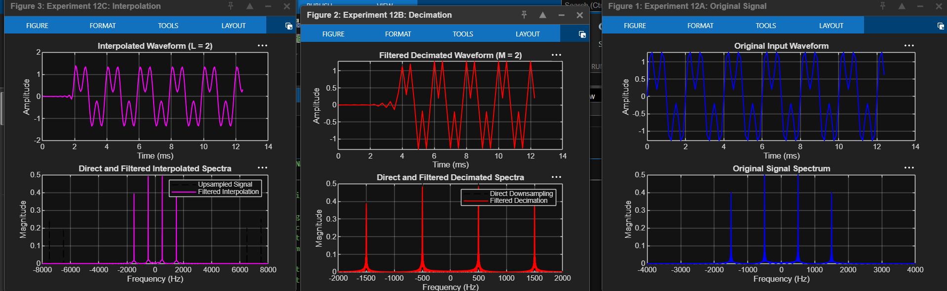
Figure 1. Original, decimated, and interpolated signal plots.
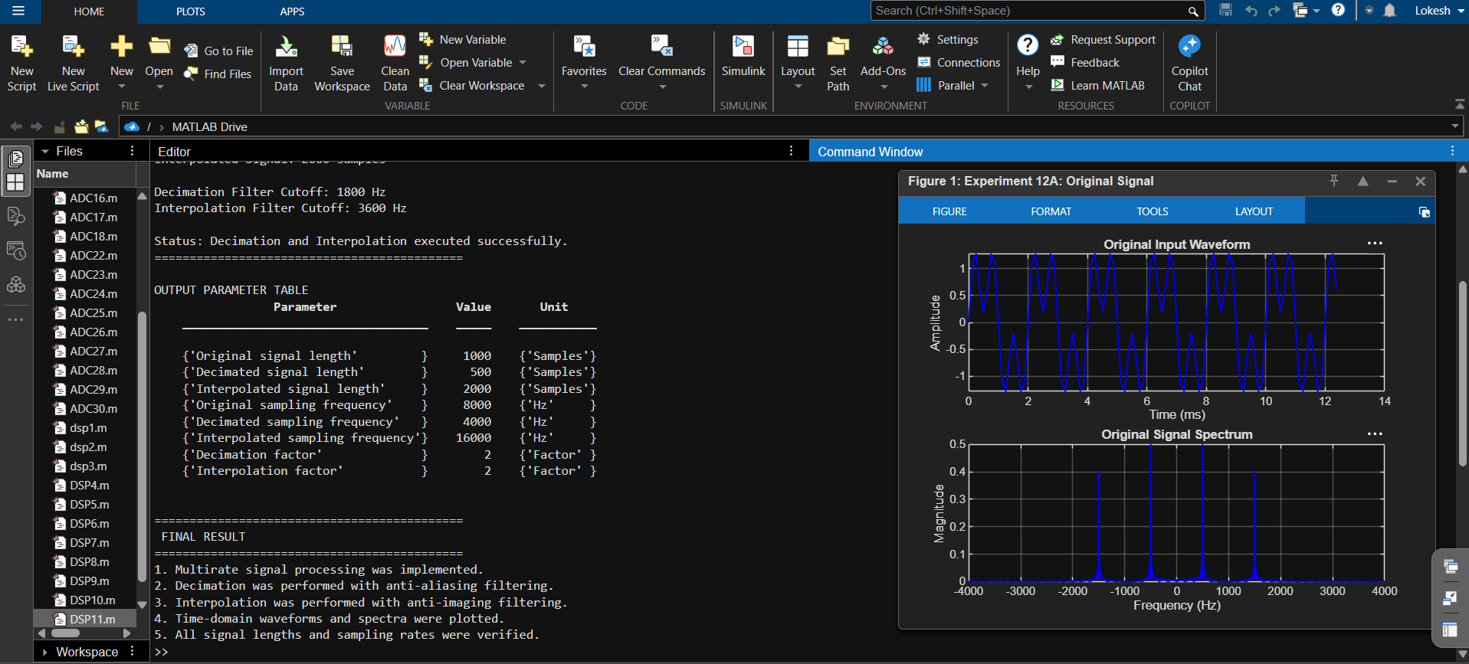
Figure 2. MATLAB command-window output, parameter table, and final result.
7. Discussion
- Decimation by a factor of 2 reduces the sample count from 1000 to 500 and changes the sampling frequency from 8000 Hz to 4000 Hz.
- The anti-aliasing FIR filter is applied before downsampling to attenuate frequency components that could alias after the sampling rate is reduced.
- Interpolation by a factor of 2 inserts zeros between the original samples, increasing the sample count from 1000 to 2000 and the sampling frequency to 16000 Hz.
- The interpolation FIR filter smooths the zero-inserted sequence and suppresses spectral images. Initial transients visible in the plots are associated with the FIR filter's finite-length response.
8. Conclusion
Decimation and interpolation were implemented successfully in MATLAB. The output lengths and sampling frequencies were verified, and the time-domain waveforms and frequency spectra were plotted. The experiment demonstrates the role of anti-aliasing and anti-imaging FIR filters in multirate digital signal processing.
Lokesh A (192512293)
B.E. Electronics and Communication Engineering (ECE)

